Arch Shape

Definition
# Source: AI Source: Provided by: [Data Path: Persons Table -> ID Column: 1, Name_En Column: Motasem Essam] -> From: [ChatGPT] on [7/25/2026]
An Arch Shape is a geometric form characterized by a curved upper boundary that spans between two endpoints or supports. Its shape may be semicircular, pointed, elliptical, parabolic, or formed by other curves.
Arch shapes appear in geometry, architecture, bridges, doorways, windows, and structural design.

Simple Definition
# Source: AI Source: Provided by: [Data Path: Persons Table -> ID Column: 1, Name_En Column: Motasem Essam] -> From: [ChatGPT] on [7/25/2026]
An arch shape is a shape with a curved top extending between two sides.
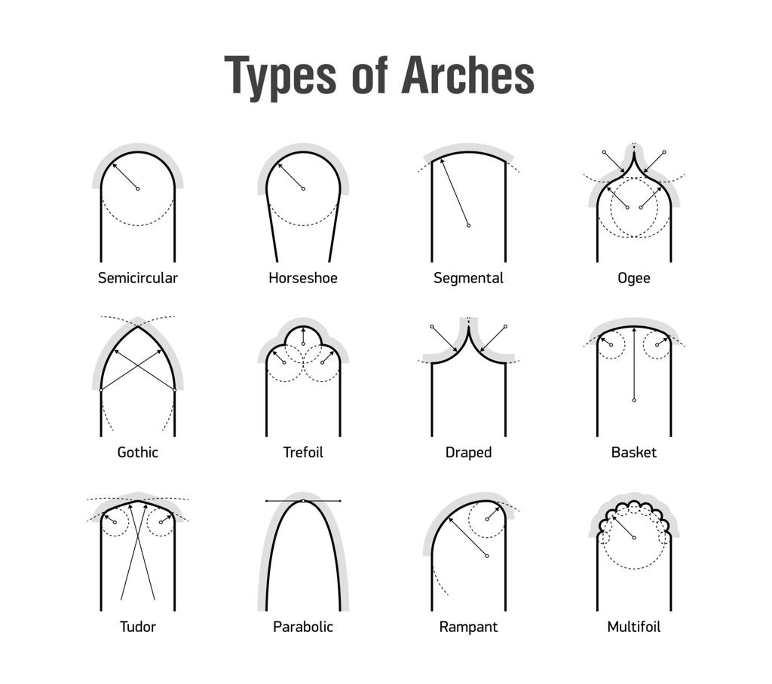

Main Classification of Arch Shapes
# Source: AI Source: Provided by: [Data Path: Persons Table -> ID Column: 1, Name_En Column: Motasem Essam] -> From: [ChatGPT] on [7/25/2026]
The following is a practical classification based on the geometry of the arch's curve. These categories are not all mutually exclusive.

1. Semicircular Arch
# Source: AI Source: Provided by: [Data Path: Persons Table -> ID Column: 1, Name_En Column: Motasem Essam] -> From: [ChatGPT] on [7/25/2026]
An arch whose curved boundary is exactly half of a circle.
Example: An arch with a span of $10$ units has a radius of $5$ units if its endpoints form the diameter.
Formula for the semicircular arc length:
$$L=πr$$
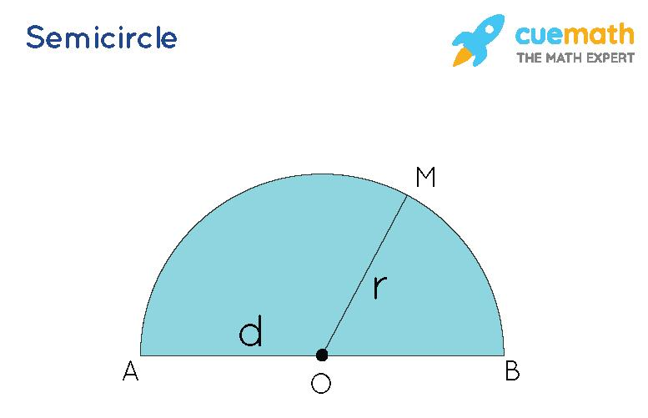

2. Segmental Arch
# Source: AI Source: Provided by: [Data Path: Persons Table -> ID Column: 1, Name_En Column: Motasem Essam] -> From: [ChatGPT] on [7/25/2026]
An arch formed by a circular arc smaller than a semicircle, with a rise less than half the span.
Example: A shallow circular arch spanning $8$ units with a rise of $2$ units.
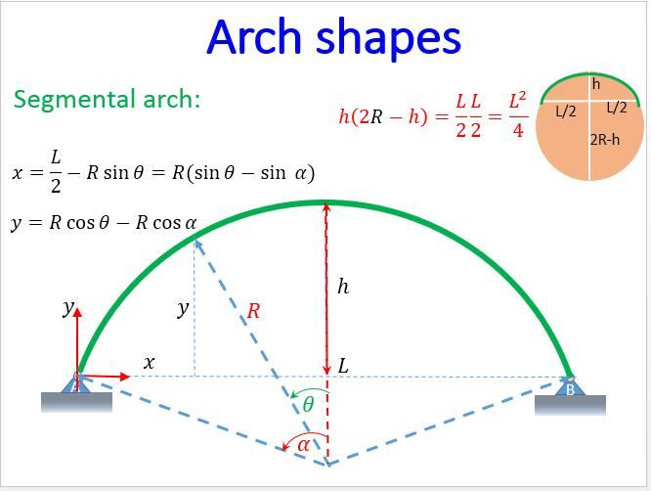

3. Elliptical Arch
# Source: AI Source: Provided by: [Data Path: Persons Table -> ID Column: 1, Name_En Column: Motasem Essam] -> From: [ChatGPT] on [7/25/2026]
An arch whose curve follows part of an ellipse. It often has a flatter profile than a semicircular arch of comparable span.
Example: An arch modeled by the upper half of an ellipse:
$$\frac{x^{2}}{a^{2}}+\frac{y^{2}}{b^{2}}=1, y≥0$$
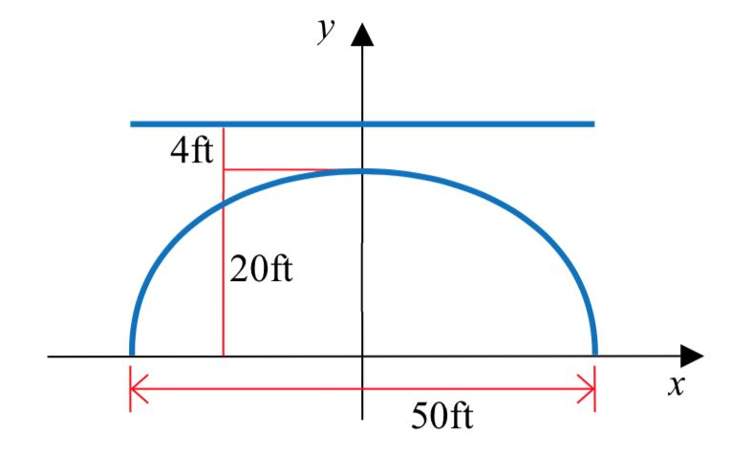

4. Parabolic Arch
# Source: AI Source: Provided by: [Data Path: Persons Table -> ID Column: 1, Name_En Column: Motasem Essam] -> From: [ChatGPT] on [7/25/2026]
An arch whose curve follows a parabola. Its profile is often used in mathematical models of bridges and structural forms.
Example: An arch with endpoints at $\left(-a,0\right)$ and $\left(a,0\right)$, and a highest point at $\left(0,h\right)$, can be modeled by
$$y=h\left(1-\frac{x^{2}}{a^{2}}\right)$$
for $-a≤x≤a$.
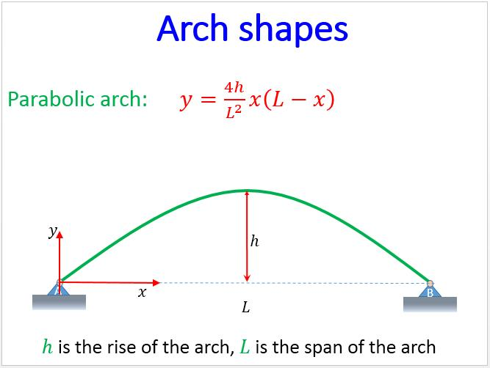

5. Pointed Arch
# Source: AI Source: Provided by: [Data Path: Persons Table -> ID Column: 1, Name_En Column: Motasem Essam] -> From: [ChatGPT] on [7/25/2026]
An arch formed by two curved sides that meet at a pointed apex. A common construction uses two circular arcs.
Example: A pointed arch with two sides meeting at the top above a doorway.
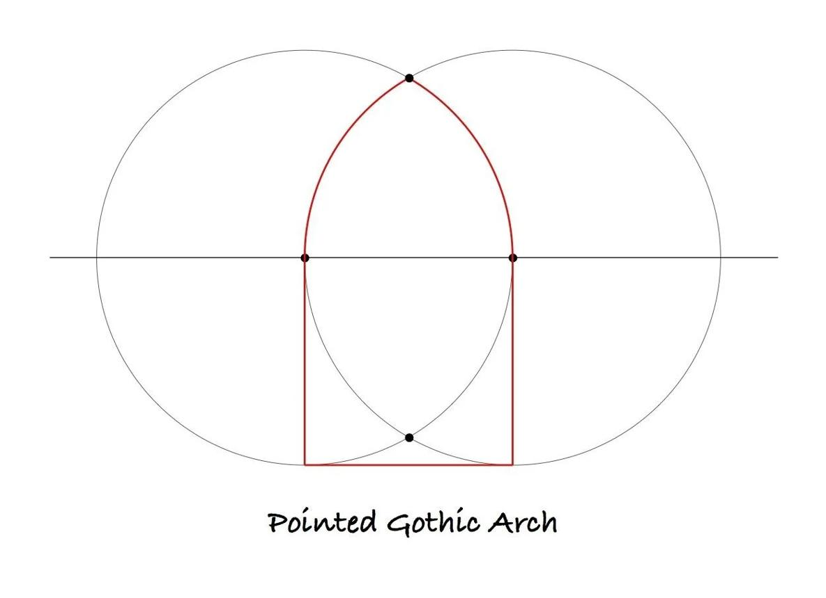

6. Gothic Arch
# Source: AI Source: Provided by: [Data Path: Persons Table -> ID Column: 1, Name_En Column: Motasem Essam] -> From: [ChatGPT] on [7/25/2026]
A pointed arch commonly associated with Gothic architecture. Its profile may be constructed from intersecting circular arcs, often with relatively steep sides.
Example: A tall pointed arch used in a Gothic cathedral window.
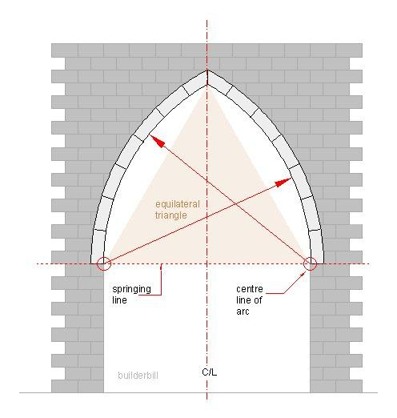

7. Horseshoe Arch
# Source: AI Source: Provided by: [Data Path: Persons Table -> ID Column: 1, Name_En Column: Motasem Essam] -> From: [ChatGPT] on [7/25/2026]
An arch that curves inward below the springing points, making the opening wider near the top than at its lower sides.
Example: A horseshoe-shaped arch found in traditional Moorish and Islamic architecture.
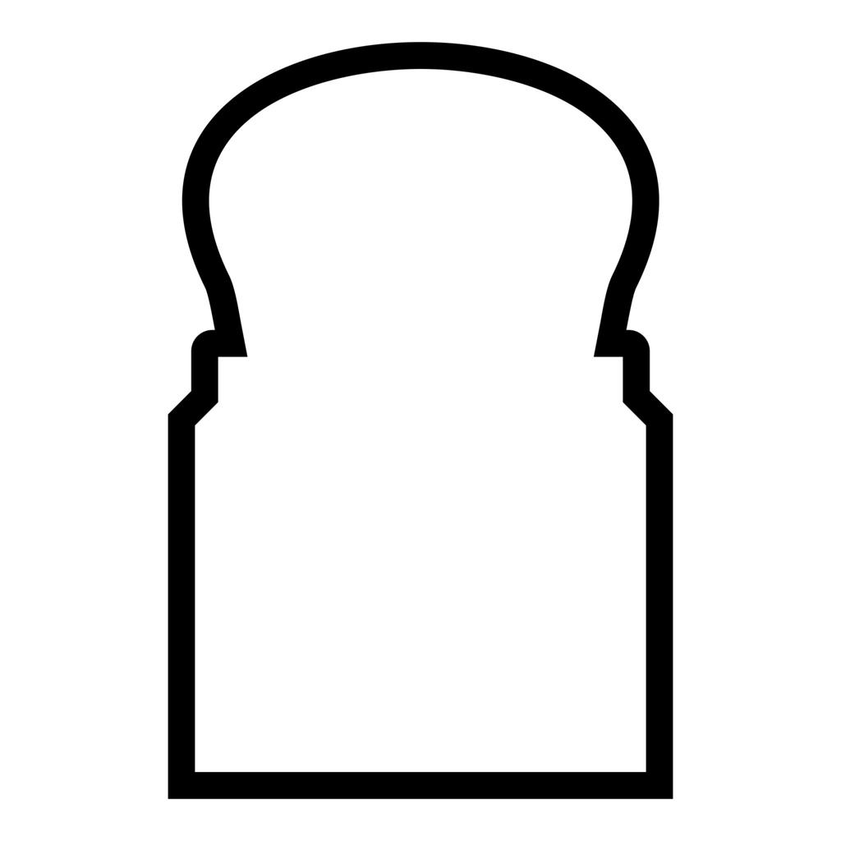

8. Flat Arch
# Source: AI Source: Provided by: [Data Path: Persons Table -> ID Column: 1, Name_En Column: Motasem Essam] -> From: [ChatGPT] on [7/25/2026]
An arch with a nearly horizontal upper profile. Some architectural flat arches use straight wedge-shaped blocks rather than a visibly curved boundary.
Example: A shallow flat arch above a window opening.
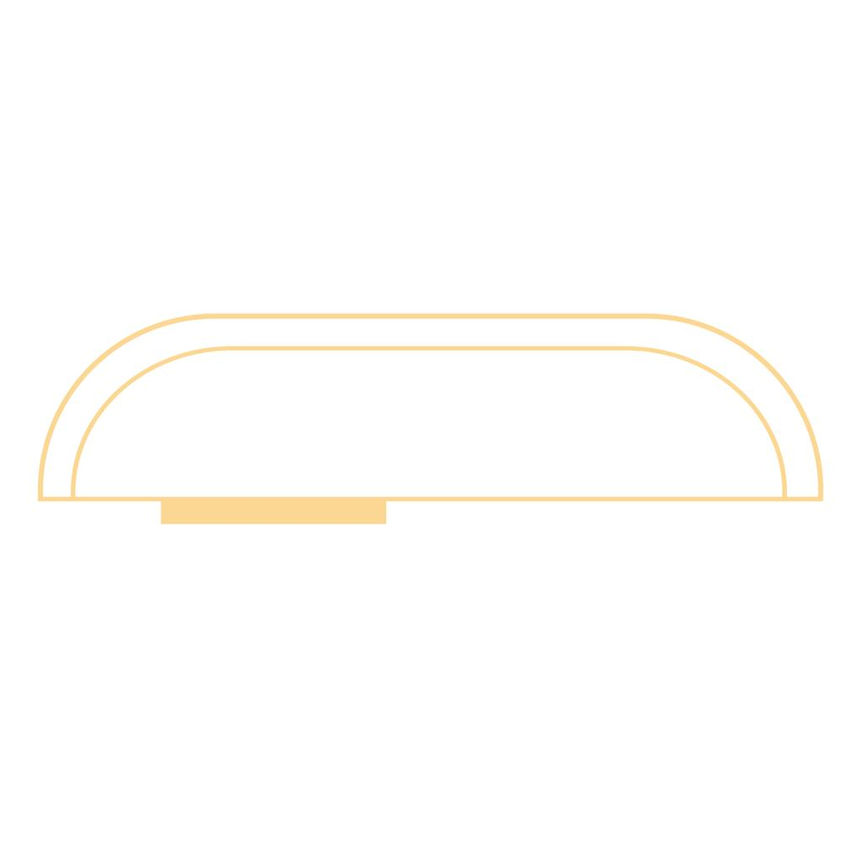

9. Three-Centered Arch
# Source: AI Source: Provided by: [Data Path: Persons Table -> ID Column: 1, Name_En Column: Motasem Essam] -> From: [ChatGPT] on [7/25/2026]
An arch formed from three circular arcs with different centers, commonly used to create a broad, relatively flat profile.
Example: A wide doorway arch made from three connected circular arcs.
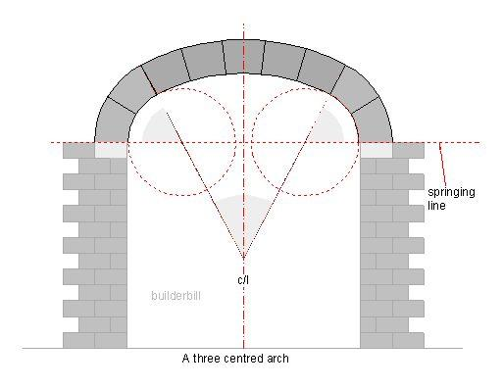

10. Freeform Arch
# Source: AI Source: Provided by: [Data Path: Persons Table -> ID Column: 1, Name_En Column: Motasem Essam] -> From: [ChatGPT] on [7/25/2026]
An arch whose curve does not follow one standard geometric form such as a circle, ellipse, or parabola.
Example: A decorative arch designed with a smooth custom curve.
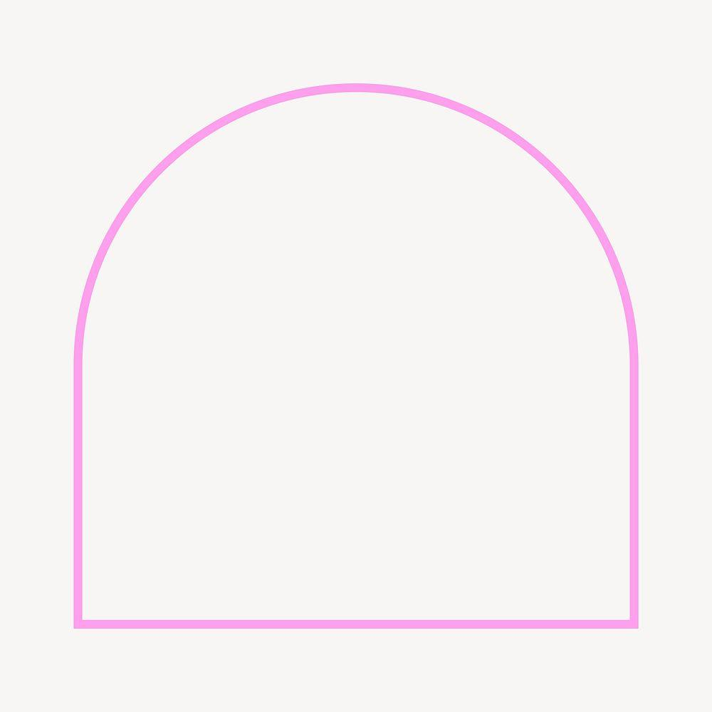

Important Geometric Parts of an Arch
# Source: AI Source: Provided by: [Data Path: Persons Table -> ID Column: 1, Name_En Column: Motasem Essam] -> From: [ChatGPT] on [7/25/2026]
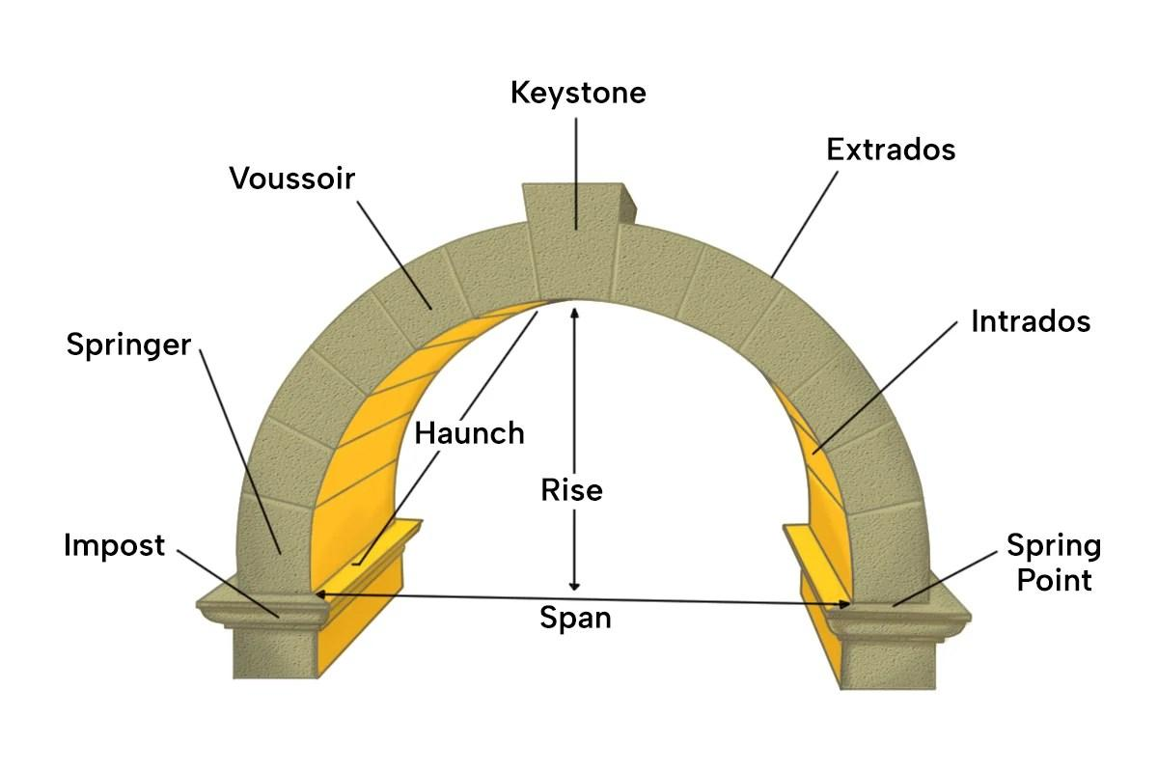
- Span: The horizontal distance between the two endpoints.
- Rise: The vertical height from the line joining the endpoints to the highest point of the arch.
- Crown: The highest part of the arch.
- Springing points: The points where the arch curve begins at its supports.
- Curve: The curved boundary connecting the endpoints.
- Axis of symmetry: A line dividing a symmetric arch into two mirror-image halves.

Mathematical Models of Arch Shapes
# Source: AI Source: Provided by: [Data Path: Persons Table -> ID Column: 1, Name_En Column: Motasem Essam] -> From: [ChatGPT] on [7/25/2026]
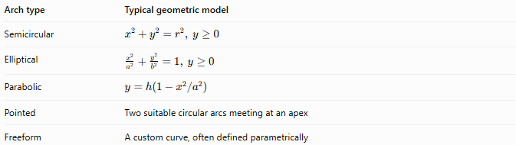
Arch type | Typical geometric model
Semicircular | $$x^{2}+y^{2}=r^{2}, y≥0$$
Elliptical | $$\frac{x^{2}}{a^{2}}+\frac{y^{2}}{b^{2}}=1, y≥0$$
Parabolic | $$y=h\left(1-x^{2}/a^{2}\right)$$
Pointed | Two suitable circular arcs meeting at an apex
Freeform | A custom curve, often defined parametrically
These equations describe common idealized profiles; real architectural arches may depart from them.

Arch Shape vs. Related Shapes
# Source: AI Source: Provided by: [Data Path: Persons Table -> ID Column: 1, Name_En Column: Motasem Essam] -> From: [ChatGPT] on [7/25/2026]
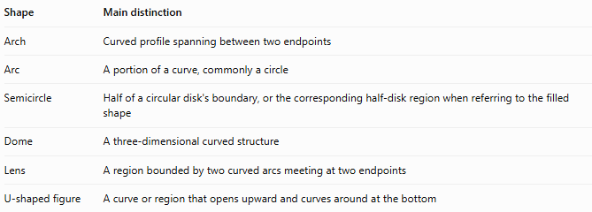
Shape | Main distinction
Arch | Curved profile spanning between two endpoints
Arc | A portion of a curve, commonly a circle
Semicircle | Half of a circular disk's boundary, or the corresponding half-disk region when referring to the filled shape
Dome | A three-dimensional curved structure
Lens | A region bounded by two curved arcs meeting at two endpoints
U-shaped figure | A curve or region that opens upward and curves around at the bottom

Classification Summary
# Source: AI Source: Provided by: [Data Path: Persons Table -> ID Column: 1, Name_En Column: Motasem Essam] -> From: [ChatGPT] on [7/25/2026]
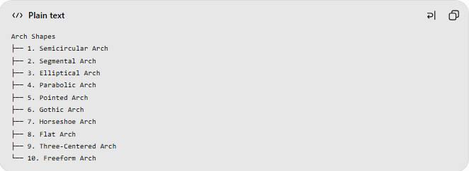
Arch Shapes
├── 1. Semicircular Arch
├── 2. Segmental Arch
├── 3. Elliptical Arch
├── 4. Parabolic Arch
├── 5. Pointed Arch
├── 6. Gothic Arch
├── 7. Horseshoe Arch
├── 8. Flat Arch
├── 9. Three-Centered Arch
└── 10. Freeform Arch
This is a practical classification combining mathematical curve types and architectural forms. For example, a Gothic arch is commonly pointed, so those categories can overlap.

Key Points
# Source: AI Source: Provided by: [Data Path: Persons Table -> ID Column: 1, Name_En Column: Motasem Essam] -> From: [ChatGPT] on [7/25/2026]
- An arch is identified by its curved profile between two endpoints.
- Its curve may be circular, elliptical, parabolic, or custom-designed.
- Span and rise are two important measurements.
- An arch may be symmetric or asymmetric.
- Architectural names describe design forms, while mathematical names describe the underlying geometry.

Conclusion
# Source: AI Source: Provided by: [Data Path: Persons Table -> ID Column: 1, Name_En Column: Motasem Essam] -> From: [ChatGPT] on [7/25/2026]
An Arch Shape is a curved geometric form spanning between two endpoints. Its classification depends on the curve's mathematical structure or its architectural profile, with semicircular, segmental, elliptical, parabolic, pointed, and freeform arches among the principal examples.

